- Log in to your MyHive Student Portal @ myhive.lynchburg.edu
- Select Student Finance tile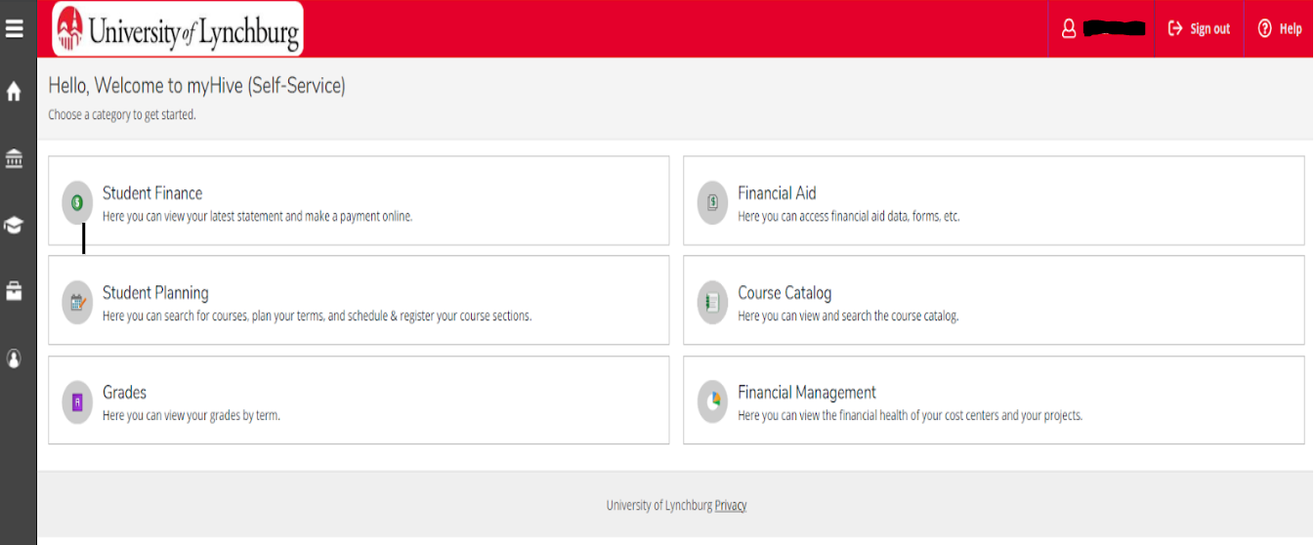

- Student Finance, select Account Summary
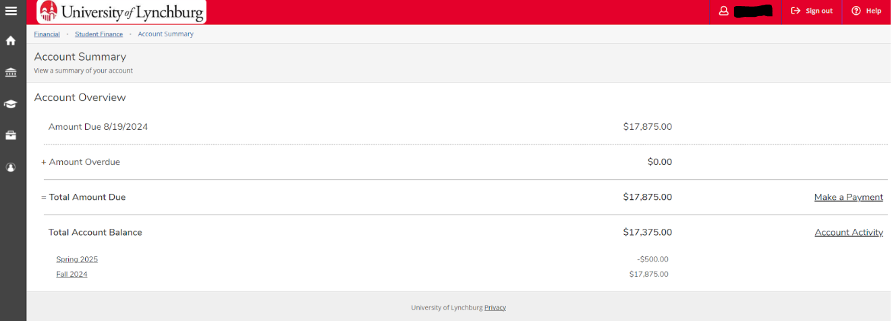

- Make a Payment – and click on the open box for the blue check box
– add in the amount desired to pay under “amount to pay” on right side
– allows for option to choose a payment method
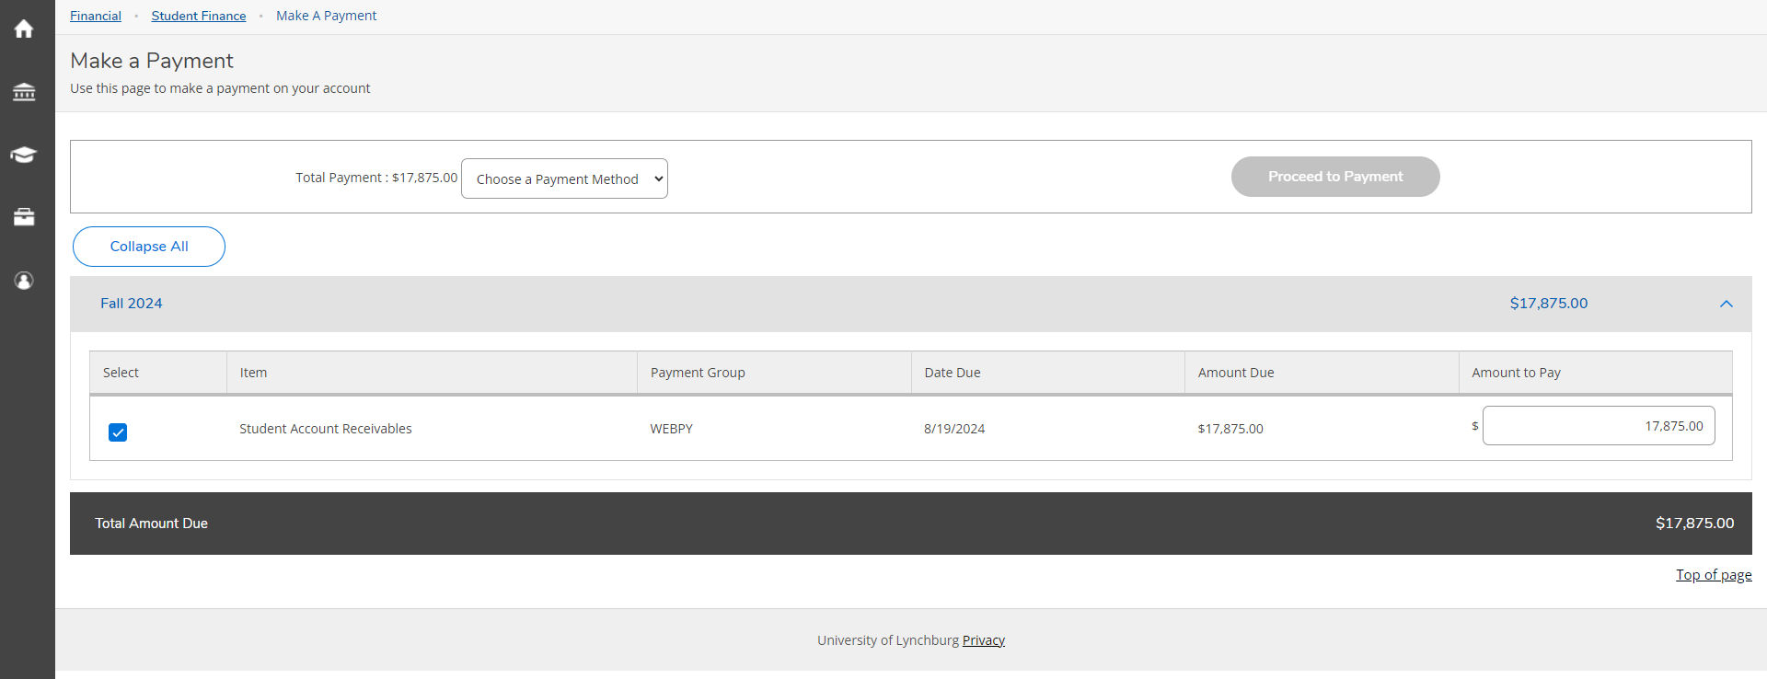

- Click on specified payment method – “proceed to payment” will light up
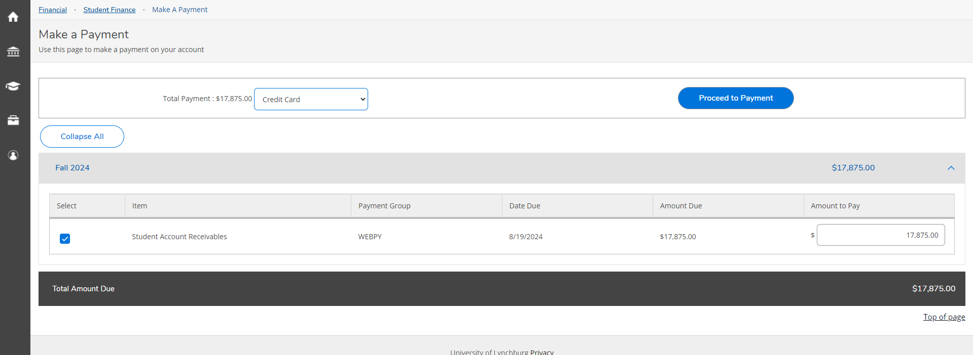

- Payment review will open up - this is showing credit card
– select “pay now”
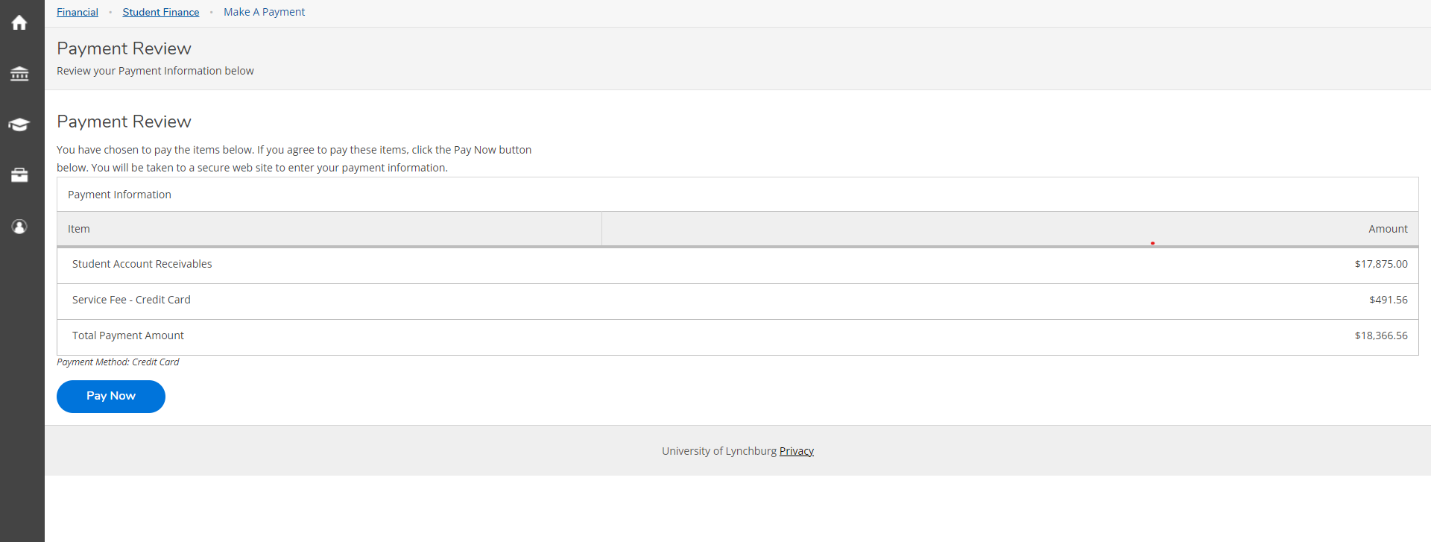

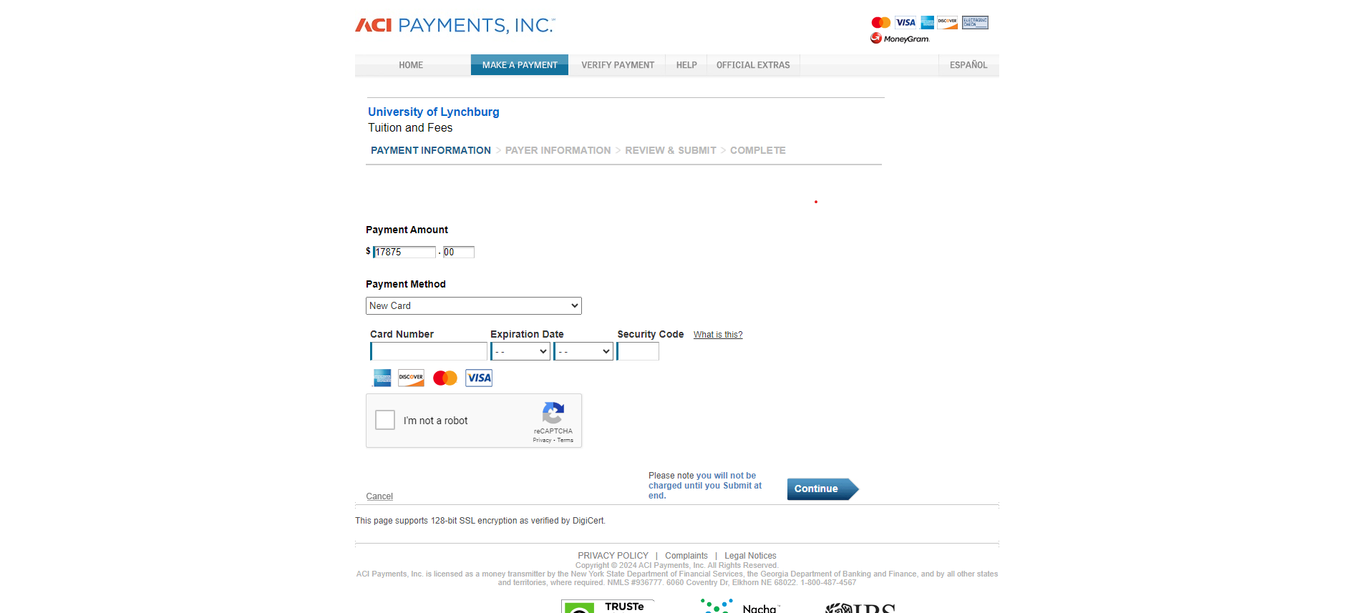
- The payment screen will show up to put in the information - this is showing the credit card option:

8) Payment Review – this is for electronic check
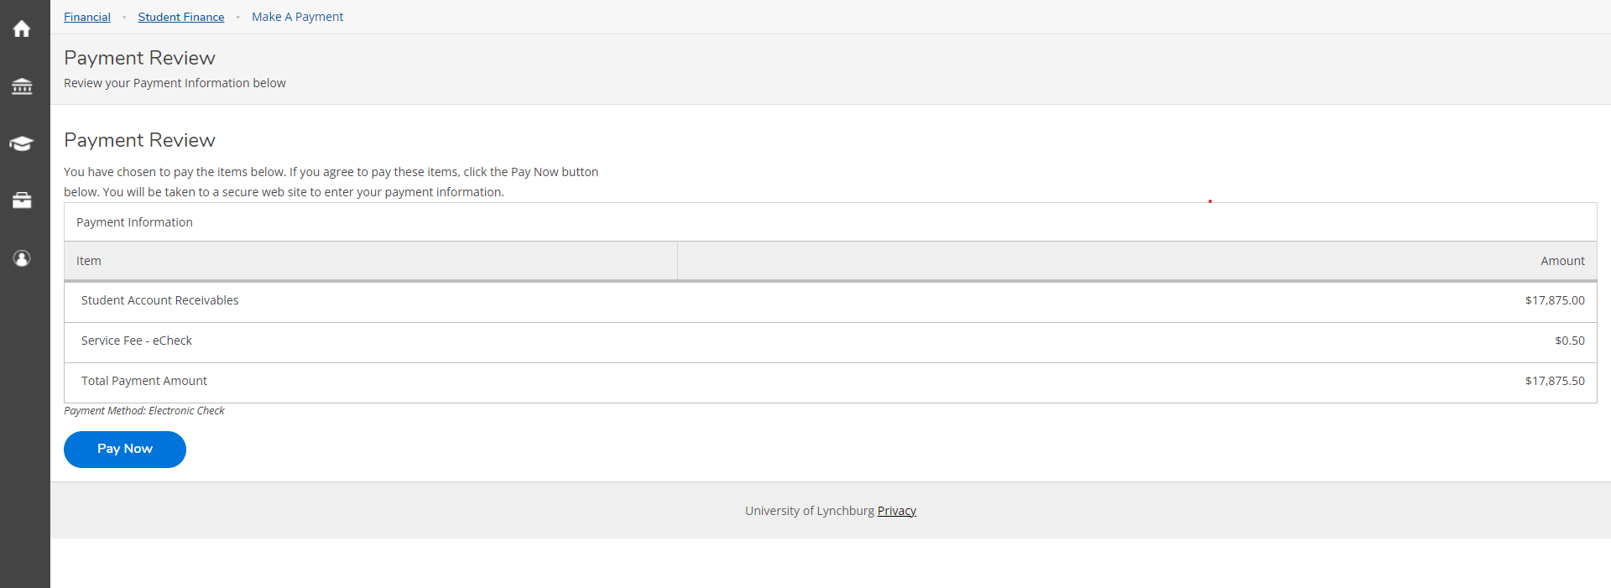
– select “pay now”

- The payment screen will show up - this is for electronic check
– the red fields auto populate with the student’s information
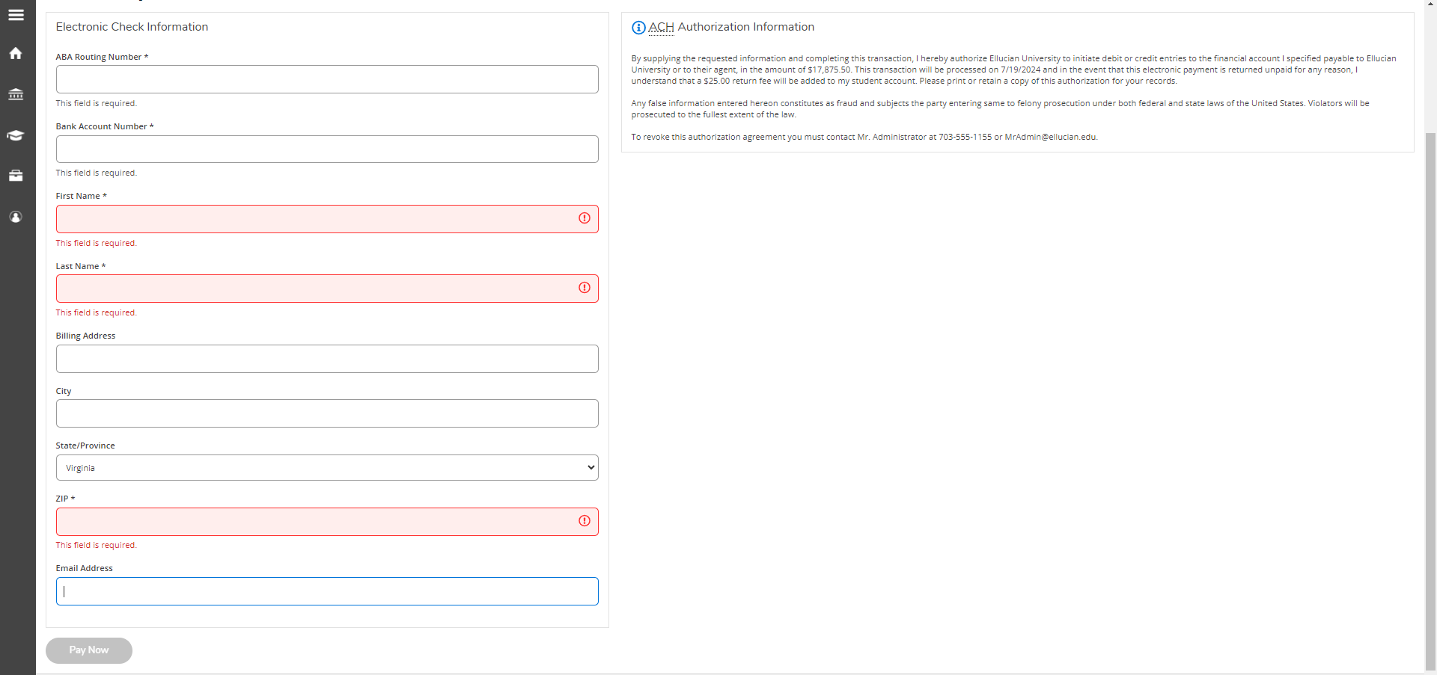
– fill in the necessary fields and select “pay now”

